**Deadline for submission of Expressions of Interest: Friday 21 October 2016**

1. **Introduction**

The Arla Foods Dairy Health and Nutrition Excellence Center has the pleasure to launch the 3rd call for ‘Expressions of Interest’ for projects to be funded in 2017.

The Center represents a long-term strategic public-private co-operation between Arla, Aarhus University, the University of Copenhagen and connected research affiliates worldwide. We foster world-class scientific research on dairy, dairy ingredients & health in areas of strategic importance to partner Universities and Arla, linking research to value creation. We use state-of-the-art tools of modern science to understand how milk and dairy products and components have the potential to impact human health and wellbeing. We wish to combine nutrition and health with environmental aspects in order to contribute to the knowledge-base of sustainable diets. The Center aims to investigate health effects of dairy and dairy ingredients in people as well as explore the basic mechanisms underlying the effect of dairy and dairy components on health. Aspects related to the milk value chain i.e. identification/characterization of active milk components, isolation and scaling up of these, in vitro and in vivo documentation of health effects and validation of these in high quality human intervention studies are of key interest.

With all this, we deliver the evidence-base for the development of new products, solutions, education and communications.

Interactions within and between Center projects and (inter)national partners are welcomed and encouraged. Center funding is to be leveraged to secure additional funding and create further networks.

The Center started in 2015 and has an initial lifetime of five years. During this period Arla is supporting the Center with 12.5 mill. DDK p.a. and each of the Universities supports the Center with 2.1 mill DDK p.a. in-kind. Center leadership is funded at 2.5 mill DKK p.a., therefore project funding equals 14.2 mill DDK p.a. (including project overhead allocated to the universities). The Center endeavors to initiate 2-4 projects annually.

1. **General guidance to the 3rd call**

With this third call we welcome applications with a focus on one of the following 3 research focus areas:

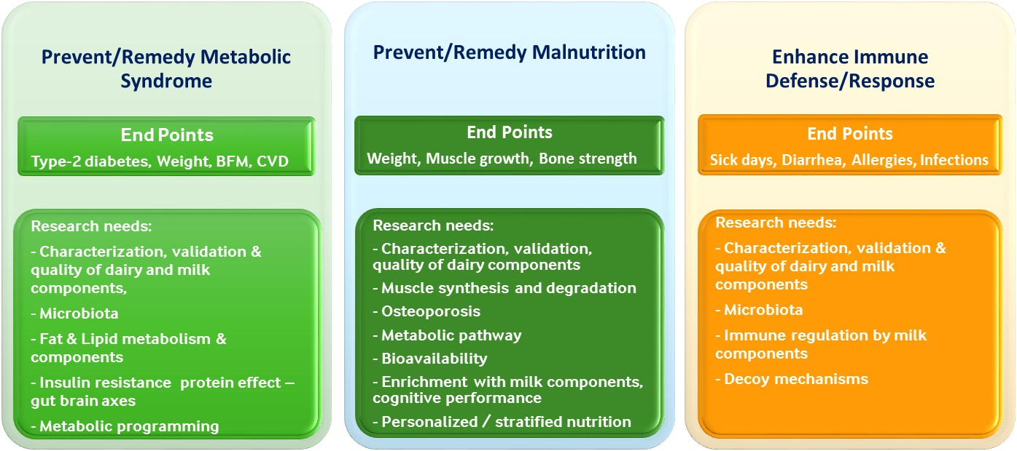

Need further information? Please contact Philip Rijken:

[philip.rijken@arlafoods.com](mailto:philip.rijken@arlafoods.com)

+4587466630

**Call for Expressions of Interest**

**Arla Foods Dairy Health & Nutrition Excellence Center**

Content

1. Introduction
2. General guidance to the 3rd call
3. Metabolic Syndrome
4. Malnutrition
5. Immune Defense/Response
6. The application procedure - 5 phases
7. Guideline/template for Expressions of Interest
8. Cluster Workshop

**4. Research Focus: Malnutrition**

Malnutrition, is a leading cause of growth attenuation in children. Adequate and optimal nutrition during childhood is fundamental to the development of each child’s full potential and to reduce illness and risk of diseases and functional disabilities also later in life. The risks presented by sub-optimal diets can start both during pregnancy and in childhood and build up throughout life. This may be addressed with nutritional strategies, possibly combined with complementary approaches.

How can we achieve optimal (catch-up) growth and development in an affordable manner and counteract malnutrition? The present call prioritizes research initiatives, which can provide a basis for further understanding of the potential of dairy in triggering mechanisms that are essential to alleviation of malnutrition.

**3. Research Focus: Metabolic Syndrome**

Only a small fraction of populations gets a balanced diet and the appropriate level of physical activity. One could say this is one of the more direct causes for why the world is faced with considerable challenges such as high rates of obesity, metabolic syndrome and cardio-metabolic conditions in general. The consequences include extensive loss of quality of life and early death, loss of productivity and economic power and loss of independence.

Benefits of food ingredients, foods, diets and new methodologies can be part of the solution, from the perspective of prevention or remediation. The present call prioritizes high-gain research initiatives on the metabolic syndrome, cardio-metabolic conditions or methodologies helping to address these, that include validated end-point parameters as well as underlying molecular mechanisms.

“Diet and lifestyle choices represent the single biggest avoidable cause for loss - and potential gain - of health and quality of life worldwide. In this context, how can we best leverage the unique nutritional properties of dairy products and ingredients?”

**5. Research Focus: Immune Defense**

Obesity and many chronic diseases share in common the presence of an inflammatory component, which partly accounts for the development of the disease. Research into the delicate checks and balances that control the human immune system is rapidly advancing. Positive effects on our immune system elicited by nutrients and by diets, for instance through the regulation of gut microbiota composition and function and through mechanisms related to epigenetics may represent innovative targets for new preventive and therapeutic strategies.

Dairy products and constituents (e.g. glycoproteins, peptides, oligosaccharides, MFGM and other fractions and ingredients) have shown anti-inflammatory potential, which is why nutrition-based solutions appear to be an obvious route to mitigate or possibly cure immune-mediated conditions.

The present call prioritizes research initiatives which provide a basic understanding of dairy and milk constituents and their characteristics in relation to their potential to mitigate or prevent immune-mediated conditions.

**Additional Guidance**

Preferred projects will include:

* Human intervention studies addressing effects on end-points in combination with deep scientific understanding (incl. mechanisms obtained though model studies) and high potential for applicability (e.g. patent opportunities, relevance for product development, input for dietary recommendations); or
* Animal model studies or prospective epidemiological studies that have high hypothesis generating potential; these could be followed up with a human intervention study in order to strengthen the hypothesis and provide a proof of principle

Preferred ‘test articles’/’products to be included in studies:

* Dairy as a whole food or as part of a diet, with a special focus on the food matrix or on the effect of the diet on health outcomes and on mechanisms of action
* Combinations of dairy with other healthy whole foods (such as fruits and/or vegetables) to explore co-benefits/synergies
* Ingredients/substances from milk

‘Sustainability’ may be included in studies as a complementary aspect:

* This could relate to methodological approaches - for example greenhouse gas footprints as related to the relative nutritional contribution of test articles to the dietary recommendations

**6. The Application Procedure - 5 phases**

The Arla Foods Dairy Health and Nutrition Excellence Center funds new projects as well as projects that are an add-on to already ongoing projects, where these address the focus areas of the present call. We operate with an objective evaluation procedure to initiate new projects. This procedure consists of 5 phases:

**Phase 1. End August 2016 – 21 October 2016. Call and submissions.**

Call for Expressions of Interest Center projects (max 5 A4 pages). Deadline submission: 21 October 2016.

**Phase 2: 21 October - 28 October 2016. Clustering.**

The clustering process is intended to assess if Expressions of Interest may be combined (it is not about selection, only combination). The process may include a workshop on 26th October (the Center Management Group and PI’s are requested to block this date in case we decide to have the workshop; the Management Group may be requested to act as facilitators of the workshop). If projects are clustered, one additional week is reserved for the PI’s involved so as to accommodate changes and prepare a combined Expression of Interest that will subsequently be submitted to the Scientific Advisory Committee (SAC).

**Phase 3: 28 October - 18 November 2016. External peer review by the Scientific Advisory Committee.**

Expressions of Interest go for external peer review on science quality by the SAC; SAC to advise on outcome by 18 November 2017.

**Phase 4: 18 November - 9 December 2016. Internal review.**

The internal review by the Center Steering Committee (SC) is about evaluation of Expressions of Interest in relation to (i) strategic fit (Arla and University perspective), (ii) business relevance (Arla perspective) and (iii) the science quality rating as given by the SAC. Projects that have a high science quality rating but low business relevance or low strategic fit will not be selected as projects should score well on all three criteria. Final ranking and selection: by 9 December 2016 (about 3 projects will be selected - depending on proposed project budgets). The Center Head will inform PI’s of outcome and feedback (a preliminary granting letter to be sent to serve follow-up applications for additional funding from other sources).

**Phase 5: 9 December 2016 - end January 2017. Principle Investigators process the feedback from SAC and SC.**

Principle Investigators will be requested to respond to the feedback from SC and SAC and resubmit a full proposal by end January 2017 (the full proposal is an extended version of the EoI – guidelines will be provided).

**Please submit Expressions of Interest to the Head of the Arla Foods Dairy Health and Nutrition Excellence Center at:** [**philip.rijken@arlafoods.com**](mailto:philip.rijken@arlafoods.com) **(application deadline: 21 October 2016). Applicants will be notified of the preliminary outcome ultimo end of December 2016. End of application process: end of January 2017.**

“Please ensure that all appropriate fields in the Expression of Interest are included (see Guideline and budget template).”

“The Expression of Interest should not exceed 5 A4 pages (excl. CVs) and must be written in English”

A guideline and a template for the project budget estimate are co-attached in the email with the Call for Expressions of Interest.

# 7. Guideline/template for Expressions of Interest

To facilitate a creative process and collaborations in the context of this call, the Arla Foods Dairy Health and Nutrition Excellence Center will organize an informal creative workshop - depending on interest.

During the workshop, PI’s will be requested to briefly present their Expression of Interest and indicate further needs or ideas for collaborations with the objective to open a dialogue with the audience.

**Date of workshop 26 October; time and venue to be announced, depending on interest**

# 8. Cluster Workshop

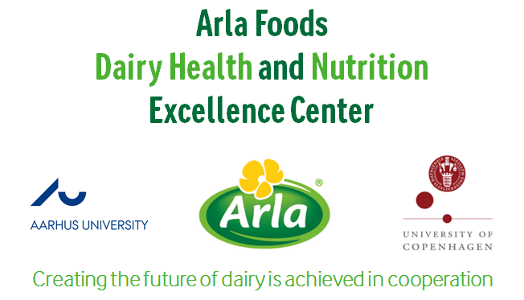

**Please direct all queries to Philip J. Rijken:**

**email:** [**philip.rijken@arlafoods.com**](mailto:philip.rijken@arlafoods.com) **phone: +45 87466630**



**CLUSTER WORKSHOP**